Background

A new ride sharing company is looking for data-backed guidance on new opportunities for market differentiation. As a new chief data strategist, the company has given you access to the company’s complete record set of rides. This data contains information about every active driver and historic ride, including details like city, driver count, individual fares, and city type.

The objective here is to build a bubble pot that showcases the relationship between four key variables:

1. Average Fare ($) per City
2. Total number of Rides per City
3. Total number of Driver per City
4. City Type (Urban, Suburban, Rural)

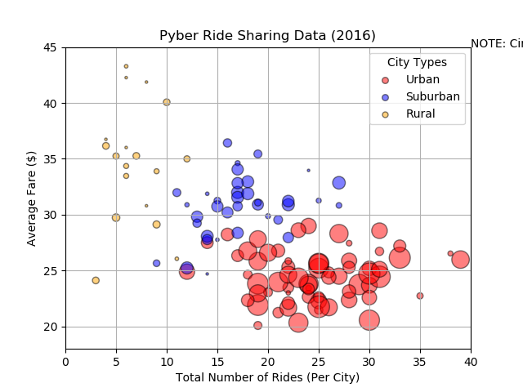

NOTE: Circle size correlates with driver count per city.

In addition, three pie charts that will show:

1. The percent of Total Fares by City type

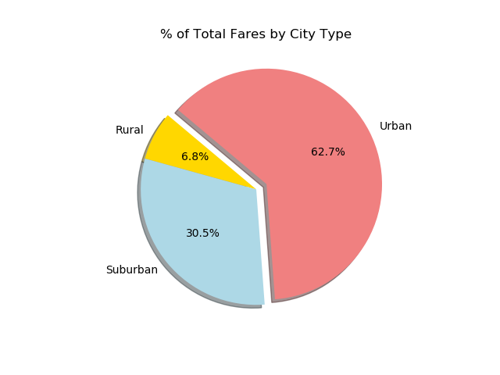

The percent of Total Rides by City type

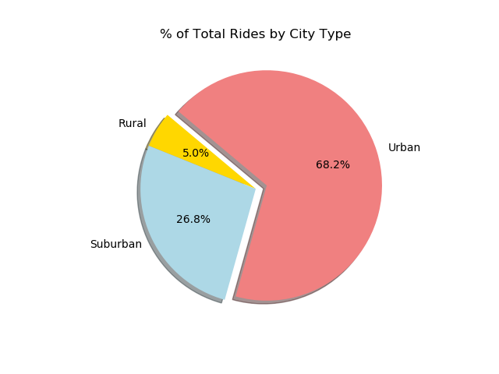

1. The percent of Total Driver by City type

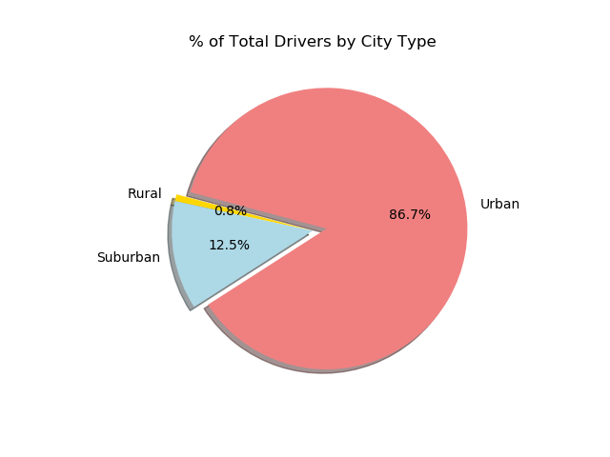

Conclusion:

According to the given data, staying cost competitive is going to be important but not for long. With notable players like Uber and Lyft, setting yourself apart is going to require some distinctive characteristics and make it visible to the target audience. The given data shows that the biggest demand is concentrated in the Urban areas but, that is where your biggest well-known competitors are. So, cost will have to be close to the current fare rate which is averaging for urban somewhere between $20 to $30. The average fare rate outside of the urban cities is higher, averaging between $25 to $35. (See scatter plot) The only limitation that I see with the given data is that it does not give an insight to your target audience. Other than controlling cost, it would be of great value to also see what consumers want from their ride sharing experience or track your marketing techniques for visibility.